**5. Design a wireframe for a mobile application that incorporates localization features using Figma.**

**Aim: -**

To design a wireframe using Figma for a mobile application that incorporates localization features

**Procedure: -**

1. open Figma

2. Create a new file

3. Select the Frames

4. Design Visual Elements

5. Make it Interactive

6. Add icons on the Frame

7. Incorporate Multimedia

8. Storyboard Animation

9. Review and edit the Prototype

10. Save and Share

**Design**:

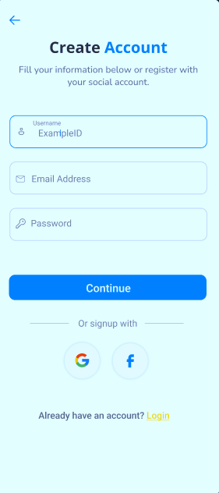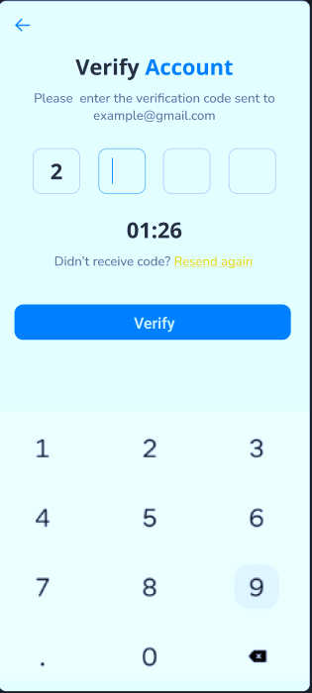

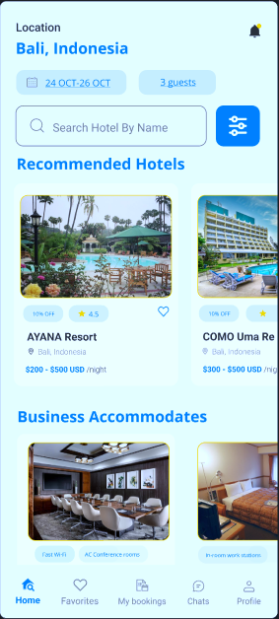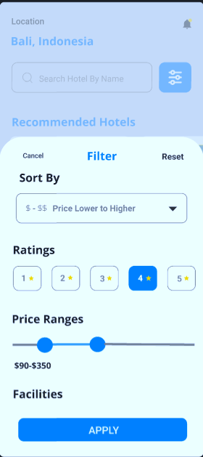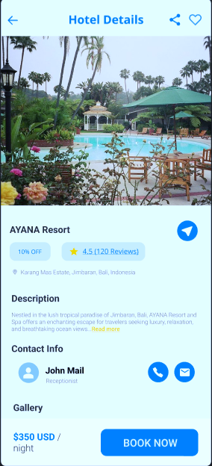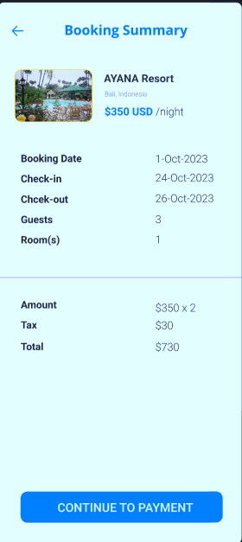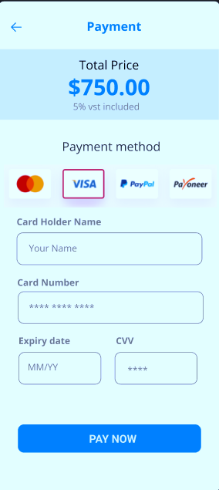

**Prototype: -**

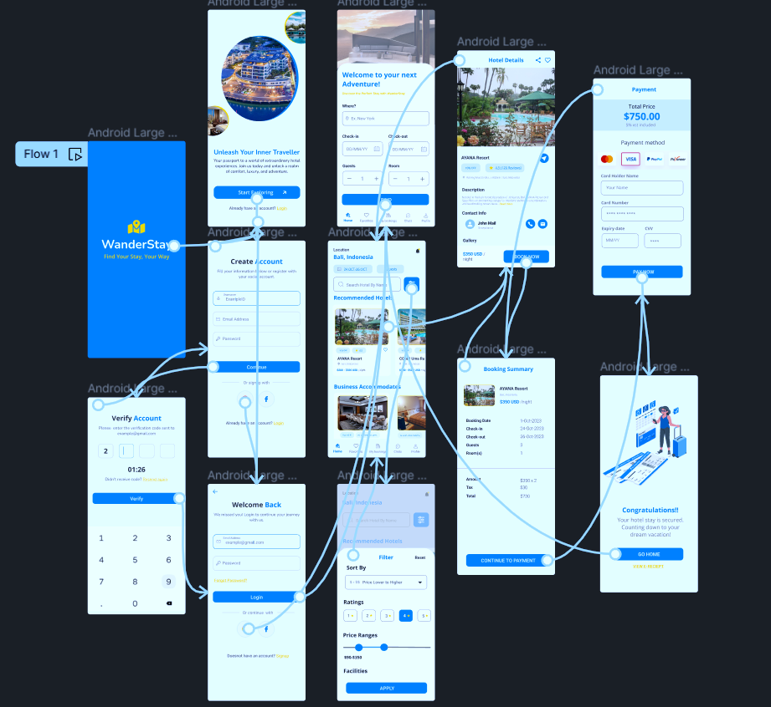

**Result: -**

Hence the wireframe for a mobile application that incorporates localization features using Figma is created and executed successfully